ORGANIZATIONS DOING HURRICANE RELIEF IN HONDURAS Loren Hintz Most were first mentioned on the Peace Corps Honduras Facebook page by RPCVs especially posts on Nov. 5 and Nov. 8. Here are their names and links. These groups do other work but are now focused on food, housing, clothing, medical care specific to the flooding from Hurricanes Eta and Iota. Many of their websites have lots of photos of the hurricane damage and recovery. Also several people mentioned specific go fund me projects based upon people they knew. I did not include them but rereading the PCH Facebook will give you that info: https://www.facebook.com/groups/2209604190 I have donated to/or have personal experience with the first 5 organizations.
Path Hurricane Iota.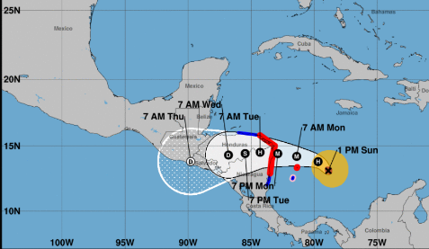
1. CAMO Central American Medical Organization (RPCV founded, focusing on western Honduras) https://www.camo.org/
2. SHI Sustainable Harvest International (RPCV founded, focusing on agriculture), https://www.sustainableharvest.org/
3. HSN Honduras Solidarity Network (of Alliance for Global Justice, supporting local groups) http://www.hondurassolidarity.org/
4. Catholic Relief Services (of CARITAS), https://www.crs.org/our-work-overseas/where-we-work/honduras
5. Solidaridad (Honduran children and education organization) https://www.facebook.com/websolidaridad/
6. AJC Children’s Foundation www.ajccf.org
7. Florida Immigrant Coalition (FLIC) https://floridaimmigrant.org/ The Florida Immigrant Coalition (FLIC) will be partnering with local organizations to provide immediate relief to impacted families.
8. Honduras Hope https://www.hondurashope.org/ Honduras Hope is a New Hampshire-based non-profit, 501(c)(3) charitable organization supporting health, education, and entrepreneurship in rural Honduras. We are 100% volunteer and travel to our sister communities four times per year. The contributions of so many each year support a variety of programs in the Honduran communities of Plan Grande, San Jose de Machigua and Yoro.
9. HEDC Honduras Educational Development Asst. https://hedac.org/hurricane-eta/ RPCV’s sister is on the board of HEDAC which is based in Chicago. HEDAC’s genesis was a result of Hurricane Mitch in 1998. Sadly, our communities, 20 years later, are again suffering as a result of Hurricane Eta. The images below give you a sense of what our communities are going through now exacerbated by being in the middle of a pandemic.
10. CEPUDO: Capacitacion, Educacion, Produccion, Unificacion, Desarrollo, Organización https://cepudohonduras.org/ CEPUDO began with a program called "Women in Development." Works with communities in Honduras to overcome conditions of extreme poverty by providing shelter for those most in need, relieving hunger through monthly aid, and bringing hope to the youth through education
11. Roatan Healthy Families https://www.facebook.com/familiassaludablesroatan/
12. Guiran, hope for the people https://www.facebook.com/guiranhn/
13. Whole Hearts Missions (Carlos David Martinez) https://www.wholeheartmissions.com/ RPCV John Kotula says he knows Carlos well and have talked with him a lot about the work his church does supporting the community. He is a very trustworthy man and you can donate to this project with complete confidence that the funds will help the people most in need.
14. La Ceiba Rotary Club https://www.facebook.com/Club-Rotario-La-Ceiba-347403445381072 George Harast’s wife is president. Email harastn@ymail.com
Amanda Browne shared 3 websites as ways to help Honduras and Nicaragua during Hurricane Eta: 15. Direct Relief https://directrelief.org 16. Pan American Health Organization (PAHO): https://paho.org/en 17. Fundación Ruth Paz: http://fundacionruthpaz.org
18. RPCV Thomas Carter: My organization aguapuraparaelpueblo.org is working in Ocotepeque department repairing community water systems, working with 19. Proyecto Aldea Global https://www.paghonduras.org/
